**Chapter**

**Revolutionizing Healthcare: Harnessing the Power of Machine Learning for Better Patient Outcomes**

**Abstract**

In recent years, the integration of machine learning and healthcare has created a promising avenue for improving patient outcomes. This thesis explores the revolutionary potential of machine learning in healthcare by examining its role in enhancing various aspects of patient care. With the help of dataset and many advanced algorithm, machine learning helps for extracting patient data that is more accurate and proactive disease management strategies. The widespread usage of machine learning in medical field has many difficulties, including issues related to data privacy, model interpretability, and regulatory compliance. This paper discusses these challenges and proposes strategies to address them, emphasizing the importance of collaboration between healthcare professionals, data scientists, and policymakers. Overall, this research highlights the transformative potential of machine learning in revolutionizing healthcare delivery and improving patient outcomes on a global scale.

**Keywords:** Keywords: machine learning, healthcare, patient outcomes, data insights, personalized treatment, proactive management, automation, administrative processes, challenges, interdisciplinary collaboration, transformative potential.

# **Introduction:**

In the recent years, the integration of machine learning and healthcare systems has ignited a paradigm shift in the way we approach patient care. This evolution holds the promise of significantly enhancing patient outcomes by leveraging the capabilities of machine learning algorithms. This paper aims to delve into the revolutionary potential of machine learning in healthcare, exploring its transformative impact on various facets of patient well-being.

Machine learning, fueled by vast datasets and advanced algorithms, empowers to extract important aspects or features of patient data. They help to diagnose diseases more accurately and also provide treatment plan according to specific needs of the patient. Furthermore, the automation capabilities of machine learning streamline administrative tasks, leading to more efficient healthcare delivery and reduced operational costs.

This paper aims to delve into these challenges and propose collaborative solutions, emphasizing the critical role of interdisciplinary cooperation between healthcare professionals, data scientists, and policymakers.

By focusing more on the transformative potential of machine learning in revolutionizing healthcare delivery, this research endeavors to pave the way for improved patient outcomes on a global scale. Through comprehensive exploration and strategic collaboration, we can harness the power of machine learning in the new era of healthcare innovation.

**ROLE OF AI AND MACHINE LEARNING IN HEALTHCARE:**

This plays a pivotal role in the realm of machine learning within healthcare, as highlighted in this paper. AI algorithms, particularly those powered by deep learning, helps machines to take decision or make prediction accurately without explicit programming. In the context of healthcare, this capability holds immense potential for transforming patient outcomes.

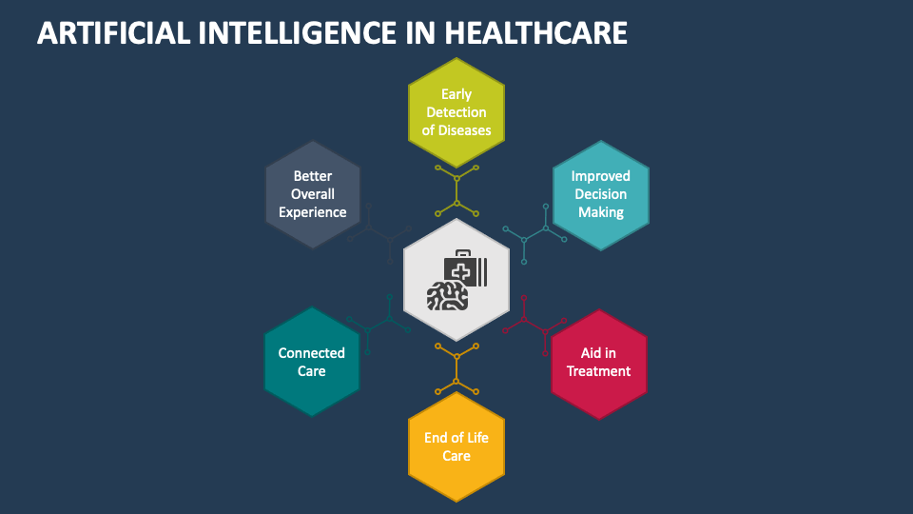

**Fig.no.1:**

*The AI healthcare figure symbolizes the fusion of artificial intelligence and healthcare, driving innovation and progress in patient care. It represents advanced algorithms and data-driven insights revolutionizing diagnostics, treatments, and administrative tasks.*

Within the framework of this paper, AI algorithms serve as the backbone of machine learning applications designed to enhance various aspects of patient care. These algorithms are used to analyze more complex data and helps to collect important information from them.

However, the integration of AI in machine learning for healthcare is not without challenges. Ensuring the correct usage of AI algorithms, addressing biases in training data, and maintaining patient privacy are critical considerations that must be carefully navigated.

Despite all these difficulties, the collaborative efforts of healthcare professionals, data scientists, and policymakers are essential in harnessing the power of AI within machine learning for better patient outcomes. Through responsible deployment, continuous refinement, and interdisciplinary collaboration, AI-driven machine learning has the potential to revolutionize healthcare delivery and improve patient outcomes on a global scale.

# **Related work**

In the pursuit of revolutionizing healthcare through the power of machine learning for better patient outcomes, several existing methods and approaches have been explored. One prominent area of research involves the application of machine learning algorithms for medical image analysis. Numerous studies have demonstrated the efficacy of convolutional neural networks (CNNs) in tasks such as tumor detection in radiological images, segmentation of anatomical structures, and classification of histopathological slides.

Another key focus within existing literature is predictive modeling for disease diagnosis and prognosis. Many machine learning techniques have been utilized to develop predictive models based on patient demographics, clinical variables, and biomarkers. These models aid clinicians in early detection, risk stratification, and treatment planning for various diseases, ranging from cancer to cardiovascular disorders.

Furthermore, natural language processing (NLP) techniques have gained traction in healthcare for extracting insights from unstructured clinical text data. NLP models enable the extraction of valuable information from electronic health records (EHRs), clinical notes, and medical literature, facilitating clinical decision-making, patient monitoring, and outcome prediction.

Additionally, the integration of wearable devices and Internet of Things (IoT) technologies has opened new avenues for remote patient monitoring and personalized healthcare delivery. Machine learning algorithms analyze data streams from wearable sensors and provide the necessary information to intended professionals.

Overall, existing methods in the field of machine learning for healthcare underscore the potential for transformative advancements in patient care.

# **Methods: Revolutionizing Healthcare**

To use the potential of machine learning (ML) for improvement of patient outcomes, our methodology integrates artificial intelligence (AI) and ML techniques across various healthcare stages. Here's an overview of our approach:

## **Data Collection and Preprocessing**

We collect large number of dataset from many sources such as wearables , medical health record datasets etc. These datasets undergo thorough preprocessing to ensure quality and consistency.

## **Feature Engineering and Selection**

In this we retrieve the required features from data. This helps in identifying the more informative features that can be used for modelling.

## **Machine Learning Model Development**

With the help of machine learning algorithms, we train models for tasks like diagnosis, risk prediction, and treatment response forecasting. Techniques like hyperparameter tuning and cross-validation optimize model performance.

## **Clinical Decision Support Systems (CDSS)**

ML models are integrated into CDSS to provide real-time decision support to healthcare providers. These systems analyze patient data and offer evidence-based recommendations for diagnosis, treatment planning, and monitoring.

## **Evaluation and Validation**

Model performance is evaluated using metrics like accuracy and sensitivity, with validation studies conducted in clinical settings to assess real-world impact. This ensures the effectiveness and usability of ML-driven interventions.

## **Ethical Considerations and Compliance**

Throughout the process, we prioritize ethical principles. Compliance with regulations like HIPAA and GDPR is ensured to protect patient rights and privacy.

By implementing these AIML-based methods, we aim to transform healthcare delivery, enhance patient outcomes, and create a more personalized and data-driven healthcare system.

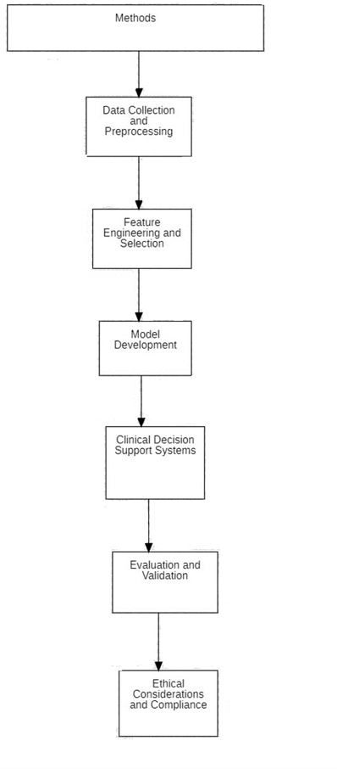

**Fig.no.2:**

*Example figure explains the architecture of the methods involved in revolutionizing healthcare. It provides a visual representation of the sequential steps, starting with data collection and preprocessing, followed by feature engineering and selection.*

# **Big data and the rise of health information**

The rise of this in healthcare has revolutionized the utilization of health information, leading to significant advancements in patient care, research, and healthcare delivery. With the digitization of medical records and the proliferation of health monitoring devices, an unprecedented volume and variety of data are being generated, collectively referred to as health big data.

The datasets provide a comprehensive view of patients' health status, medical history, behaviours, and environmental factors, enabling healthcare organizations to gain deeper insights into population health, disease trends, and individual patient needs.

One of the key advantages of health big data is its potential to drive evidence-based decision-making and personalized medicine. By analysing large-scale datasets, healthcare providers can identify undetectable pattern, leading to more accurate diagnoses, tailored treatment plans, and proactive interventions.

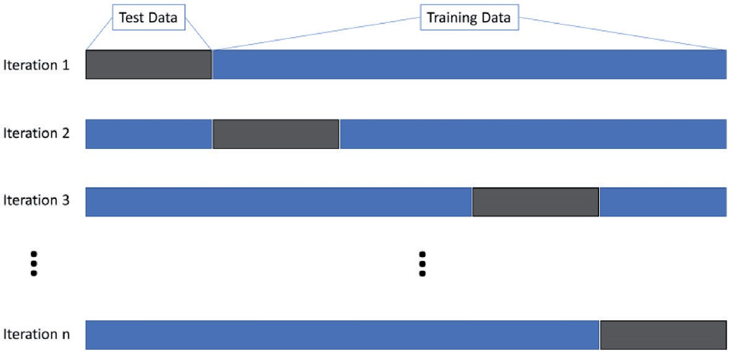

**Fig.no.3:**

The diagram illustrates the process of splitting data into training and testing sets for machine learning algorithms, with iterations for model refinement. The process iterates as the model is refined, with adjustments made based on the testing results to improve its performance. Ultimately, this iterative process ensures that the machine learning model effectively learns from the data and can make accurate predictions on unseen data, contributing to better healthcare outcomes.

For instance, data analytics can help identify gaps in care, optimize care pathways, and predict hospital readmissions, allowing for proactive interventions to prevent adverse events.

However, the utilization of health big data also presents challenges. Ensuring data interoperability and standardization is crucial for integrating disparate data sources and enabling seamless information exchange across healthcare systems.

# **Medical image machine learning**

Medical image machine learning is a rapidly growing field to analyse and interpret medical images and histopathology slides using ML algorithms.

One of the primary applications of medical image machine learning is in image segmentation, where algorithms are trained to identify and delineate specific structures or abnormalities within medical images. For example, in MRI brain scans, machine learning models can segment different brain tissues with high accuracy, aiding radiologists in diagnosis and treatment planning.

Another key area of focus is in image classification, where images are categorized as different classes based on their characteristics. For instance, in mammography, machine learning models can classify mammographic images as either benign or malignant, assisting in early breast cancer detection.

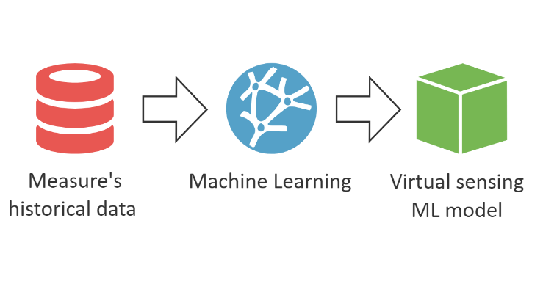

**Fig.no.4:**

The flow diagram illustrates the process of utilizing historical medical image data to train a machine learning (ML) model and then applying this model to perform virtual sensing tasks. Initially, historical medical image data is collected and preprocessed to extract relevant features. This data is then used to train a machine learning model, which learns patterns and relationships from the images. Once the model is trained, it is deployed as a virtual sensing tool, capable of analysing new medical images and extracting valuable insights without the need for manual intervention

Medical image machine learning also plays a crucial role in image registration, where algorithms align and fuse multiple imaging modalities or time-series images to provide a comprehensive view of the patient's anatomy or pathology. This is particularly valuable in surgical planning and image-guided interventions.

By analysing longitudinal imaging studies, such as serial MRI scans, these models can provide clinicians with valuable insights into disease trajectories and guide personalized treatment decisions.

However, the adoption of medical image machine learning is not without challenges. Large-scale annotated datasets are often required to train accurate models, and the labelling of medical images can be consume more time.

In conclusion, medical image machine learning holds immense potential for revolutionizing healthcare by enhancing the accuracy and efficiency of medical image analysis. As the field continues to advance, with ongoing research and technological innovations, it promises to play an increasingly vital role in clinical practice, ultimately improving patient care and outcomes.

**Integration of Natural Language Processing in Clinical Decision Support Systems**

The integration of these two represents a significant advancement in healthcare technology, offering potential benefits in diagnostic accuracy, treatment planning, and patient care.

In CDSS, NLP techniques are used to process vast amounts of textual data, transforming it into structured and actionable insights. This includes tasks such as named entity recognition, which identifies and categorizes entities like medical conditions, medications, and procedures mentioned in text. Additionally, entity linking connects these entities to standardized medical terminologies, ensuring interoperability and accuracy.

One of the primary applications of NLP in CDSS is in improving clinical documentation and coding. NLP algorithms can analyze clinical notes to identify relevant diagnoses, procedures, and other key information, facilitating accurate coding for billing and reimbursement. Furthermore, NLP-powered CDSS can assist clinicians by providing contextually relevant information, clinical guidelines, and alerts based on the analyzed data, thereby enhancing clinical decision-making and patient safety.

However, the integration of NLP in CDSS also presents challenges, including the need for robust algorithms, data privacy concerns, and ensuring the accuracy and reliability of extracted information. Despite these challenges, they are used for improving healthcare outcomes and streamlining clinical workflows.

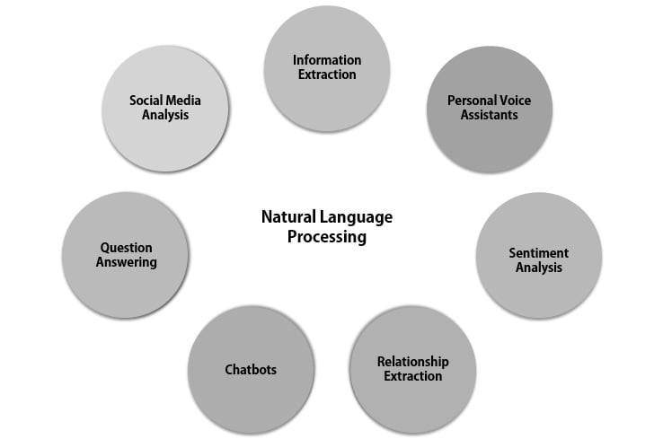

**Fig..no.5:**

The diagram demonstrates how these technologies contribute to enhancing healthcare delivery and decision-making processes. Through techniques like information extraction and relationship extraction, NLP algorithms identify medical concepts, key clinical events, and relationships between entities, providing insights that aid in clinical decision-making and care coordination.

Moreover, the integration of NLP-powered tools like chatbots, personal video assistants, and question answering systems further enhances the capabilities of CDSS. These tools facilitate natural language interactions between patients and healthcare systems, providing assistance with appointment scheduling, medication reminders, and answering medical inquiries. Furthermore, personal video assistants enable personalized medical advice and educational content tailored to individual patient needs, while question answering systems offer clinicians quick access to relevant medical knowledge and guidelines at the point of care. Overall, the integration of these NLP attributes into CDSS streamlines clinical workflows, improves diagnostic accuracy, and ultimately leads to better patient outcomes in healthcare.

**Hereditary qualities machine learning for complicated illness information and prediction**

Hereditary qualities machine learning for complicated malady information and expectation is a cutting-edge field that leverages progressed computational strategies to analyze hereditary information and unwind complex malady instruments. With the appearance of high-throughput sequencing innovations, tremendous sums of genomic information are created, advertising phenomenal openings for understanding the hereditary premise of different infections, counting cancer, cardiovascular disarranges, and neurological conditions.

In this field, machine learning calculations are connected to decode complicated designs inside genomic information and reveal covered up connections between hereditary varieties and malady phenotypes. These calculations can handle the complexity and tall dimensionality of genomic information, permitting analysts to recognize hereditary markers, gene-gene intuitive, and pathways related with infection vulnerability and movement. For illustration, directed learning strategies such as back vector machines and arbitrary woodlands can be prepared on labeled genomic datasets to foresee illness chance or treatment reaction based on hereditary features.

Moreover, hereditary qualities machine learning approaches empower the integration of differing information sorts, counting genomic, transcriptomic, epigenomic, and clinical information, to give a comprehensive understanding of infection science. By combining multi-omics information with progressed machine learning procedures, analysts can disentangle the complex interaction between hereditary and natural components in malady advancement. For occurrence, integrator approaches like profound learning and Bayesian systems can capture complex intuitive between qualities, proteins, and natural variables to illustrate malady instruments and distinguish novel restorative targets.

One of the key focal points of hereditary qualities machine learning is its potential to encourage personalized medication by fitting medicines to person patients based on their hereditary profiles. By analyzing genomic information from huge cohorts, machine learning models can stratify patients into subgroups with unmistakable infection subtypes or treatment reactions, empowering more focused on and successful treatments. Furthermore, hereditary qualities machine learning can help in the revelation of biomarkers for early illness discovery, forecast, and observing, permitting for opportune intercessions and moved forward quiet outcomes.

However, the application of hereditary qualities machine learning in complicated illness information and forecast too presents challenges. Issues such as information quality, test estimate, and populace heterogeneity can influence the execution and generalizability of machine learning models. Moreover, deciphering the comes about of machine learning examinations in the setting of infection science requires intrigue collaboration between computational scholars, geneticists, and clinicians. In spite of these challenges, hereditary qualities machine learning holds gigantic guarantee for progressing our understanding of complex illnesses and deciphering genomic bits of knowledge into clinically noteworthy information for personalized medication.

# **Conclusion**

The integration of machine learning (ML) and healthcare systems holds tremendous promise for improving patient outcomes. ML facilitates the automation of routine tasks, streamlining administrative processes and reducing healthcare costs. Interdisciplinary collaboration between healthcare professionals, data scientists, and policymakers is crucial for overcoming these challenges and realizing the transformative potential of ML in revolutionizing healthcare delivery on a global scale.

Artificial intelligence (AI) plays a pivotal role in the integration of ML in healthcare, particularly in tasks such as medical image analysis and predictive modelling for disease diagnosis and prognosis. AI algorithms analyze complex medical data to extract insights and assist healthcare providers in making informed decisions. The fusion of AI and healthcare symbolizes hope for improved patient outcomes and a more efficient healthcare system. However, ethical considerations, biases in training data, and the interpretability of AI models remain challenges that must be addressed through collaborative efforts.

Existing literature demonstrates various methods and approaches in ML for healthcare, including medical image analysis, predictive modelling, natural language processing (NLP), and the integration of wearable devices and Internet of Things (IoT) technologies for remote patient monitoring. These approaches underscore the potential for transformative advancements in patient care and highlight the importance of leveraging AI and ML to revolutionize healthcare delivery.

Our methodology for revolutionizing healthcare integrates AI and ML techniques across various stages, including data collection and preprocessing, feature engineering and selection, model development, integration into clinical decision support systems (CDSS), and evaluation and validation. By prioritizing ethical considerations and compliance with regulations, we aim to create a more personalized and data-driven healthcare system that enhances patient outcomes and improves the quality of care globally. Through continuous refinement and interdisciplinary collaboration, we can unlock the full potential of AI and ML in healthcare and pave the way for a brighter future in patient care.

# **References**

[1]Obermeyer, Z., & Emanuel, E. J. (2016). Predicting the Future—Big Data, Machine Learning, and Clinical Medicine. New England Journal of Medicine, 375(13), 1216–1219. https://doi.org/10.1056/nejmp1606181

[2]Rajkomar, A., Dean, J., & Kohane, I. (2019). Machine Learning in Medicine. New England Journal of Medicine, 380(14), 1347–1358. https://doi.org/10.1056/nejmra1814259

[3]Esteva, A., & Kuprel, B. (2017). Dermatologist-level classification of skin cancer with deep neural networks. Nature, 542(7639), 115–118. https://doi.org/10.1038/nature21056

[4]Gulshan, V., Peng, L. (2016). Development and Validation of a Deep Learning Algorithm for Detection of Diabetic Retinopathy in Retinal Fundus Photographs. JAMA, 316(22), 2402–2410. https://doi.org/10.1001/jama.2016.17216

[5]Miotto, R., Wang, F., & Wang, S. (2017). Deep learning for healthcare: review, opportunities and challenges. Briefings in Bioinformatics, 19(6), 1236–1246. https://doi.org/10.1093/bib/bbx044

[6]Zech, J. R., Badgeley, M. A., & Liu, M. (2018). Variable generalization performance of a deep learning model to detect pneumonia in chest radiographs: A cross-sectional study. PLOS Medicine, 15(11), e1002683. https://doi.org/10.1371/journal.pmed.1002683

[7]Lipton, Z. C., & Kale, D. C. (2016). Learning to Diagnose with LSTM Recurrent Neural Networks. arXiv preprint arXiv:1511.03677.

[8]Beam, A. L., & Kohane, I. S. (2018). Big data and machine learning in health care. JAMA, 319(13), 1317–1318. https://doi.org/10.1001/jama.2018.3537

[9]Obermeyer, Z., & Lee, T. H. (2017). Lost in Thought—The Limits of the Human Mind and the Future of Medicine. New England Journal of Medicine, 377(13), 1209–1211. https://doi.org/10.1056/nejmp1705348

[10]Chen, J. H., Asch, S. M., & Horng, S. (2019). Developing Predictive Models for Clinical Decision Support: Methods and Strategies. AMIA Annual Symposium Proceedings, 2019, 427–436. https://pubmed.ncbi.nlm.nih.gov/32308803/